41.32: See Example 41.3; 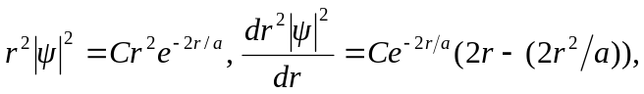 and for a maximum, r = a, the distance of the electron from the nucleus in the Bohr model.

